**Setup by Setup Approach to configure Cloudera Cluster using CM**

**Step 1: Create VMs**

I have created 4 VMs with below specification on google cloud.

* 1 Master Node :    4 CPU, 15GB RAM
* 3 Slave nodes  :     2 CPU, 9GB RAM
* All nodes have 30GB root mount point
* All are Red Hat enterprise 7 machines

sudo -I (on all node):-

**Step 2: Disable SELinux** (on all node):-

First thing, all Red Hat machines have default SELinux (Security Enhance Linux) enabled. This is how you do it. Edit config file and  disabled "SELINUX" property.

sudo vi /etc/selinux/config

...

SELINUX=disabled

...

3. **Set swappiness to 0 in /etc/sysctl.conf file**. (on all node):-

In the latest Cloudera CDH releases, it actually recommends changing to non-zero value, like 10. But for my little test, I set it to 0 like many people did.  
**vm.swappiness=0**

4: Firewall stop (on all node):-

systemctl status firewalld

5:- (on all nodes)

vi /etc/ssh/sshd_config

#change the three properties:-

**PermitRootLogin yes**

**PasswordAuthentication yes**

**ChallengeResponseAuthentication yes**

sudo passwd

systemctl restart sshd.service

then try to ssh from master to slave-1, slave-2, slave-3

6:- install java on all nodes:-

sudo yum install java-1.7.0-openjdk-devel

7:- install wget

Yum install wget

**\*\*\*\*\*\*\*\*\*\*\*\*\*\*\*\*\*\*\*\*\*\*\*\*\*\*\*\* Restart you VM “init 6”\*\*\*\*\*\*\*\*\*\*\*\*\*\*\*\*\*\*\*\*\*\*\*\*\*\*\*\*\*\*\*\*\*\***

**8:- Download and Run the Cloudera Manager Server Installer**  
All of the installations are under **root** user.  
Run the following commands.

|  |  |
| --- | --- |
| 1  2  3 | wget http://archive.cloudera.com/cm5/installer/latest/cloudera-manager-installer.bin  chmod u+x cloudera-manager-installer.bin  ./cloudera-manager-installer.bin |

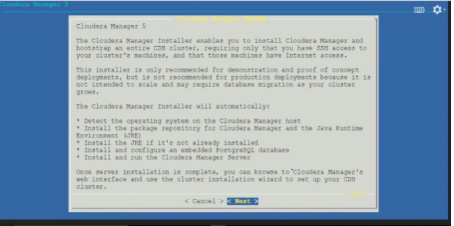

Press enter for **<Next>**

Again press **<Next>** to agree to the Cloudera Express License

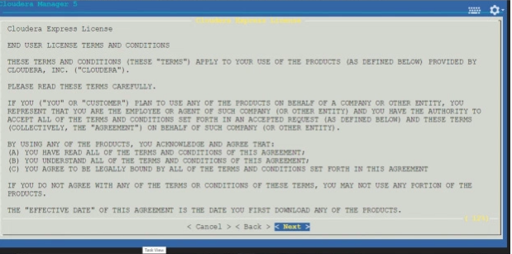

Click on **<Yes>**

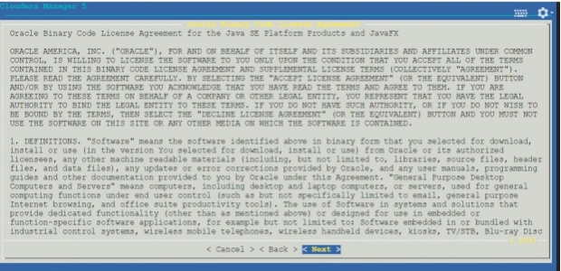

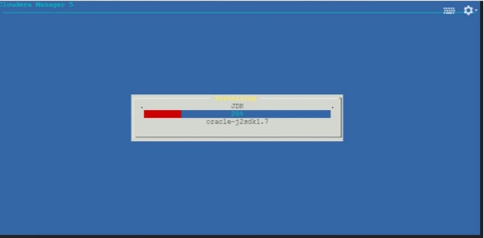

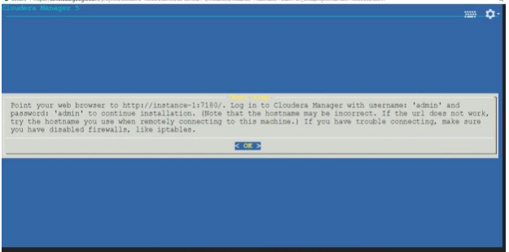

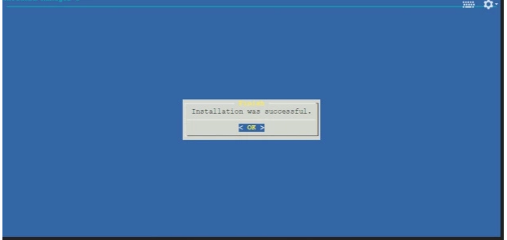

Congratulations for the successful installation !!

Firewall setup at google cloud:- (go to Google Cloud and do the below setting)

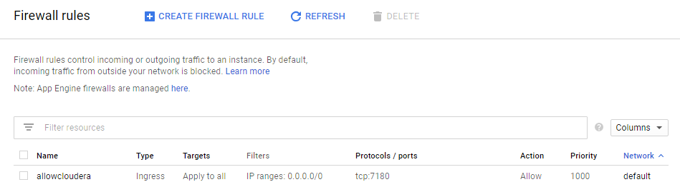

Go to browser and <http://master-ip:7180> “usrname:- admin” , passwd:- admin  
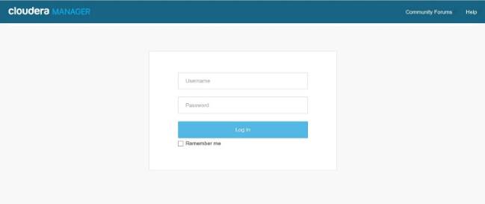

/usr/share/cmf/uninstall-cloudera-manger.sh -> to uninstall above installed bin

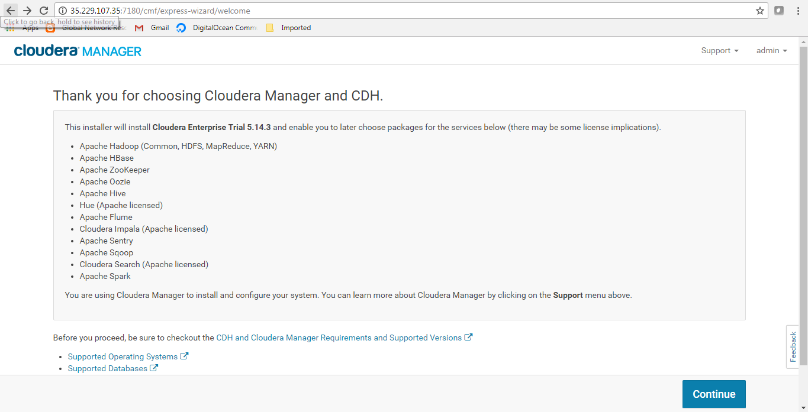

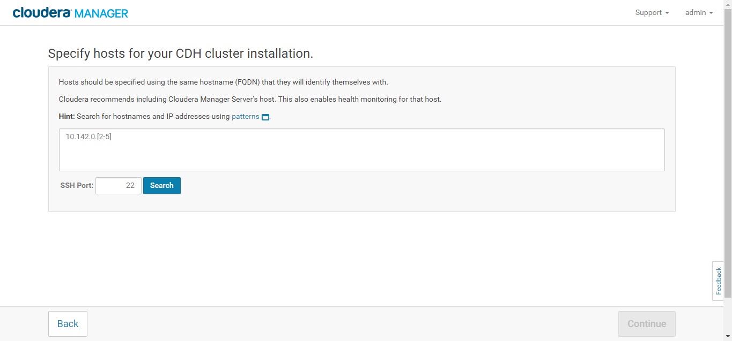

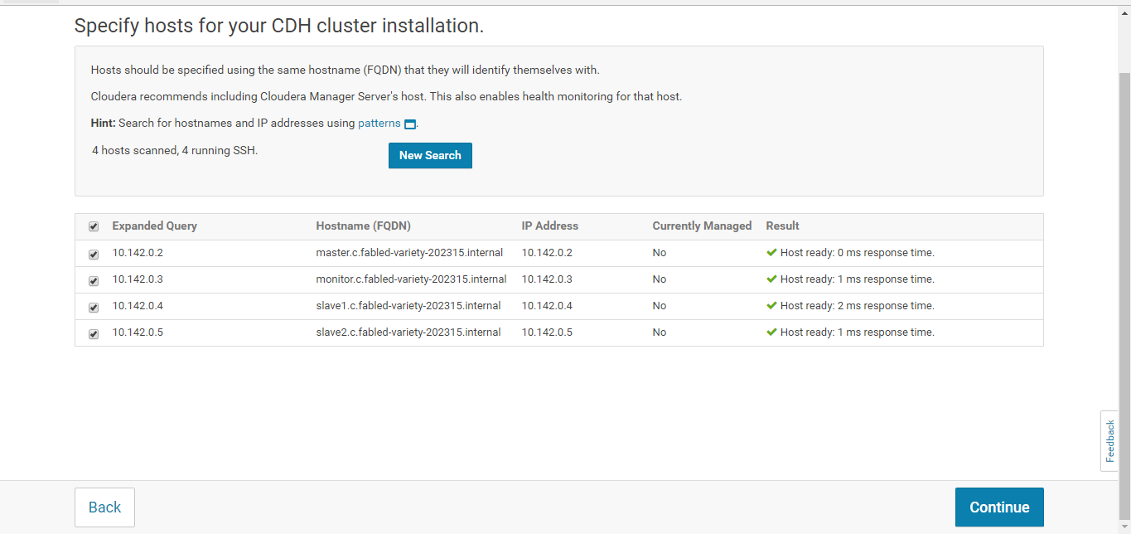

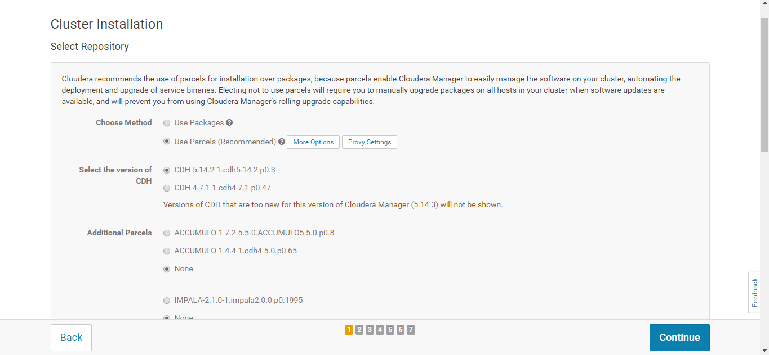

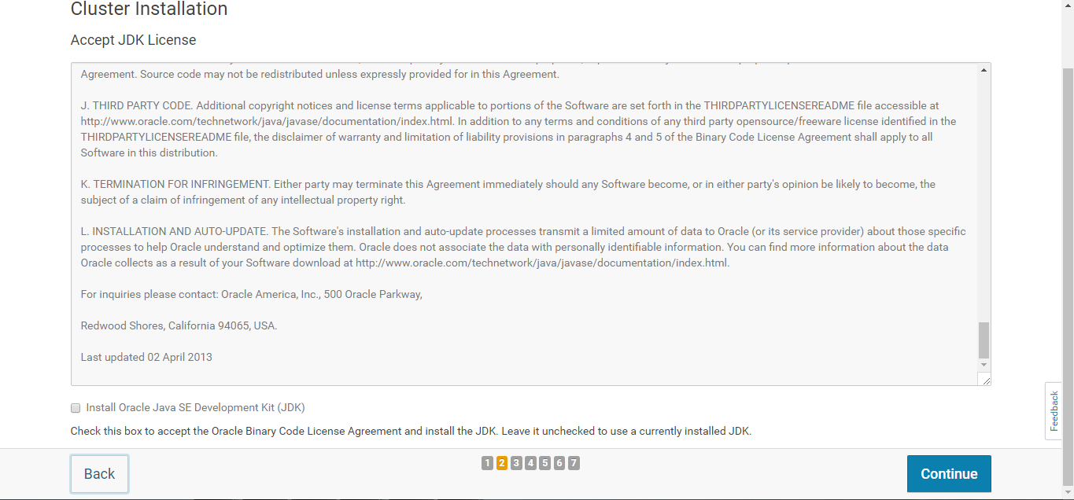

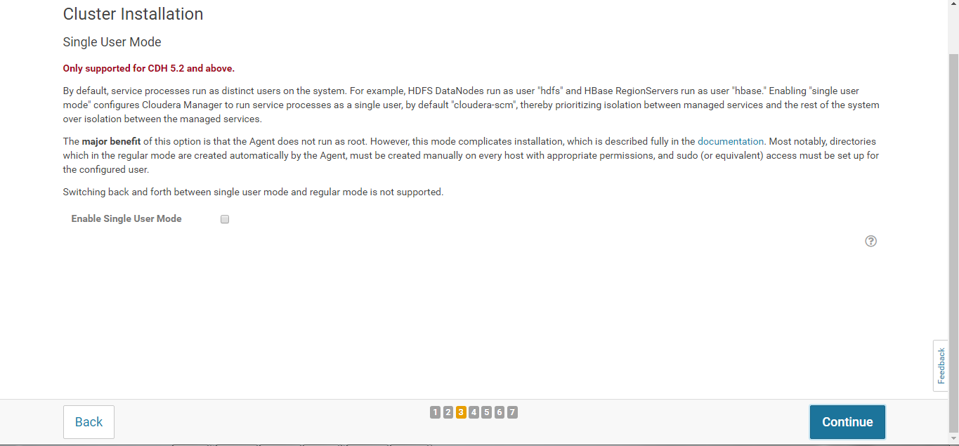

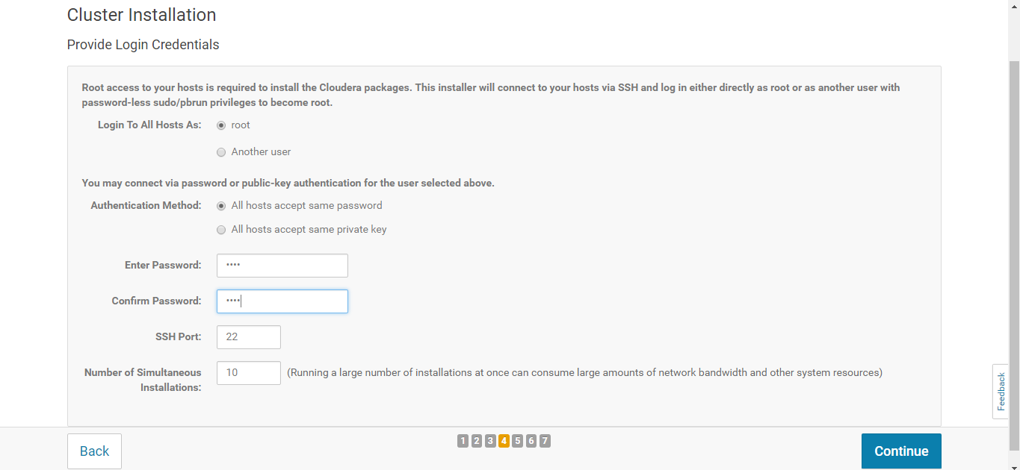

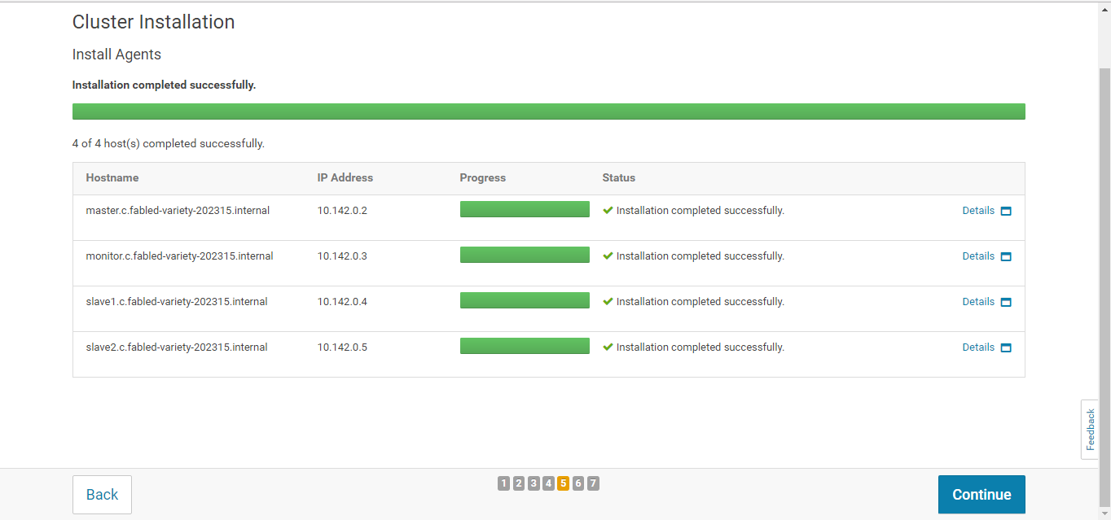

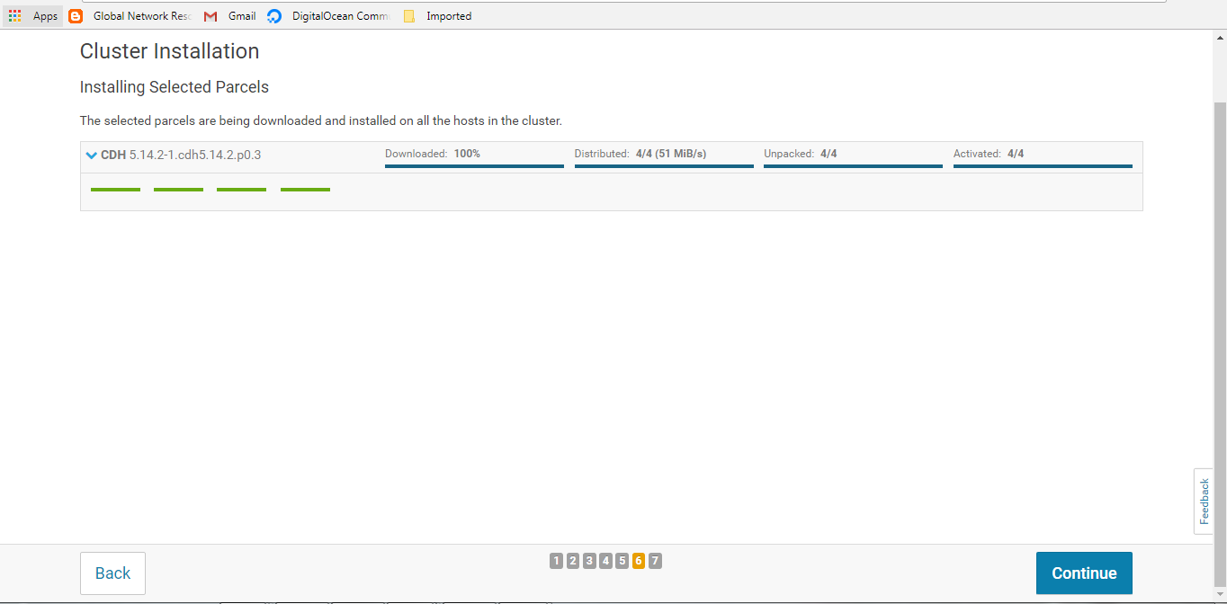

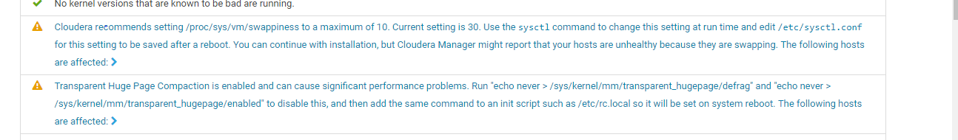

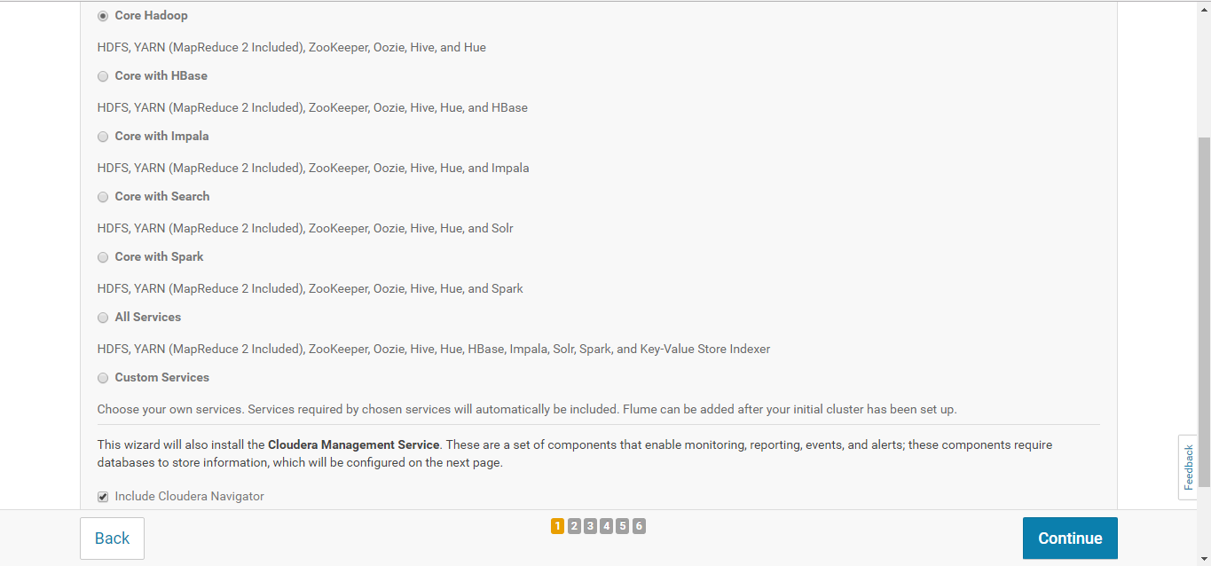

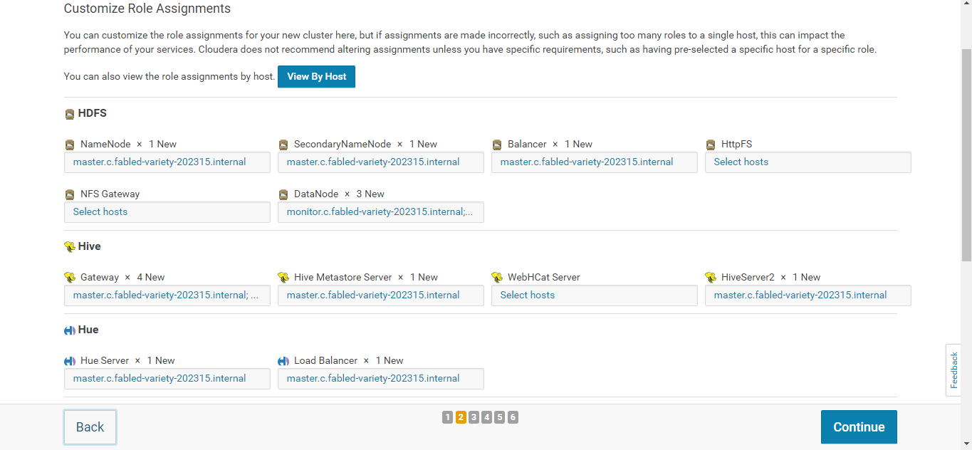

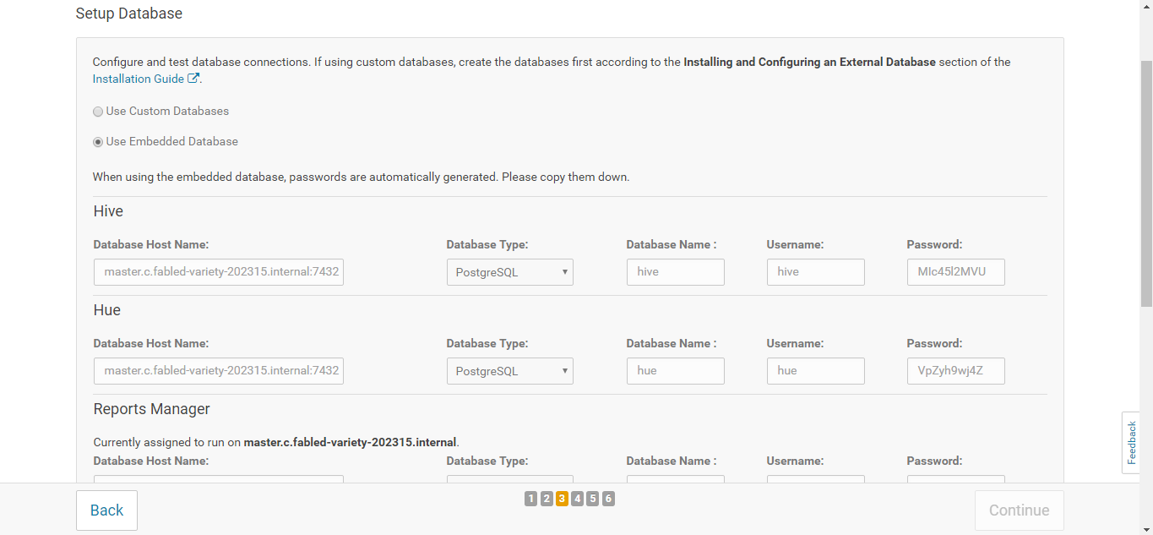

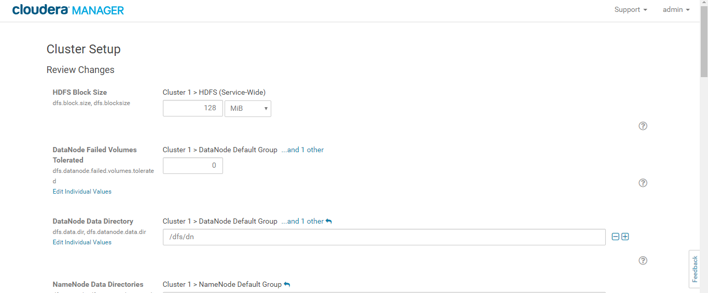

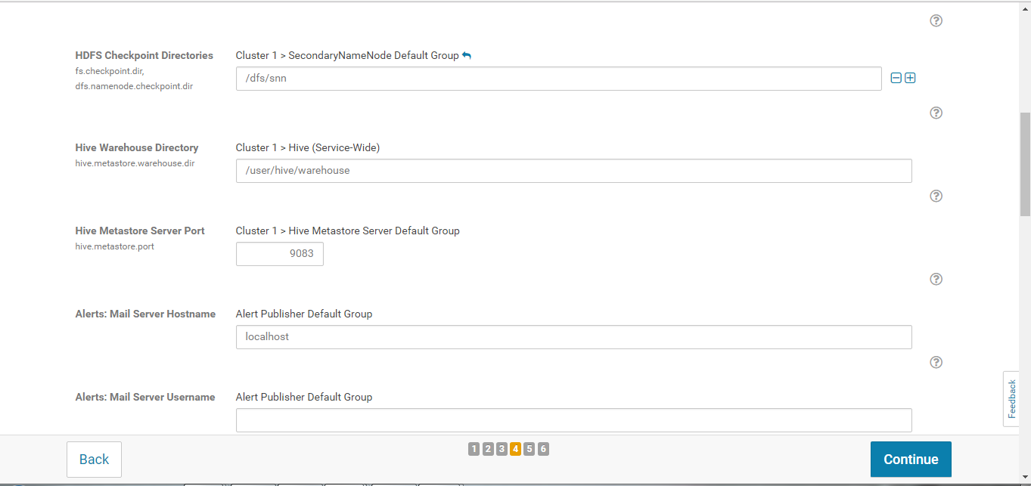

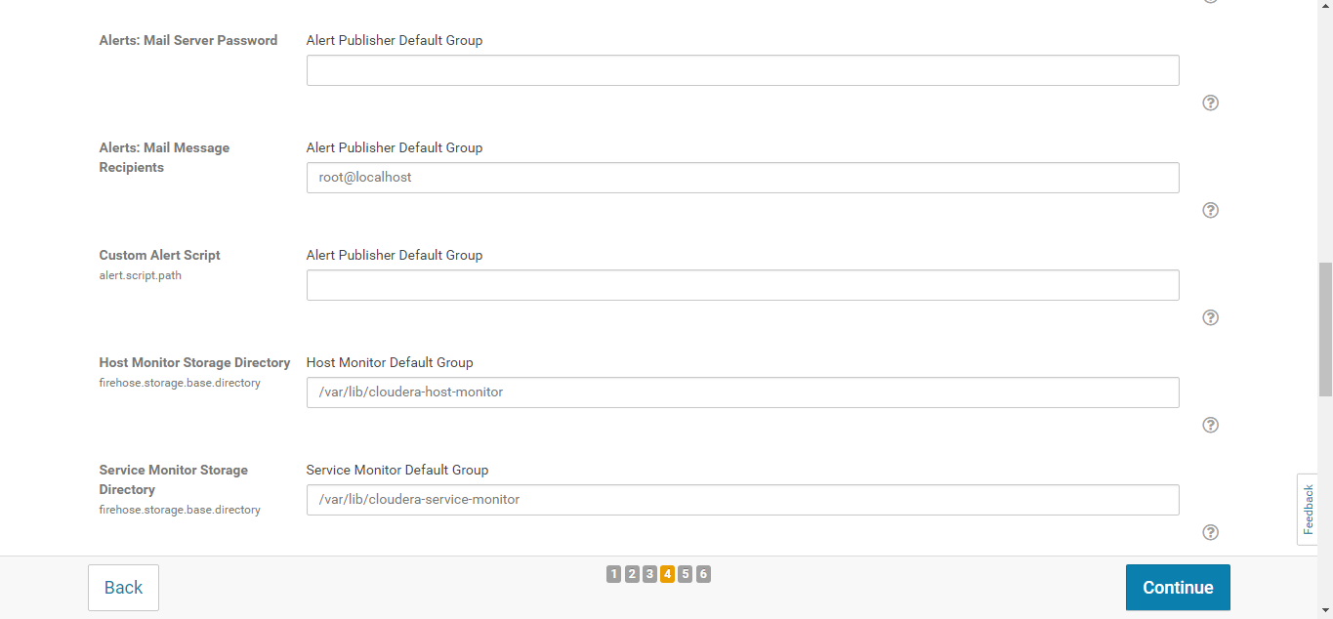

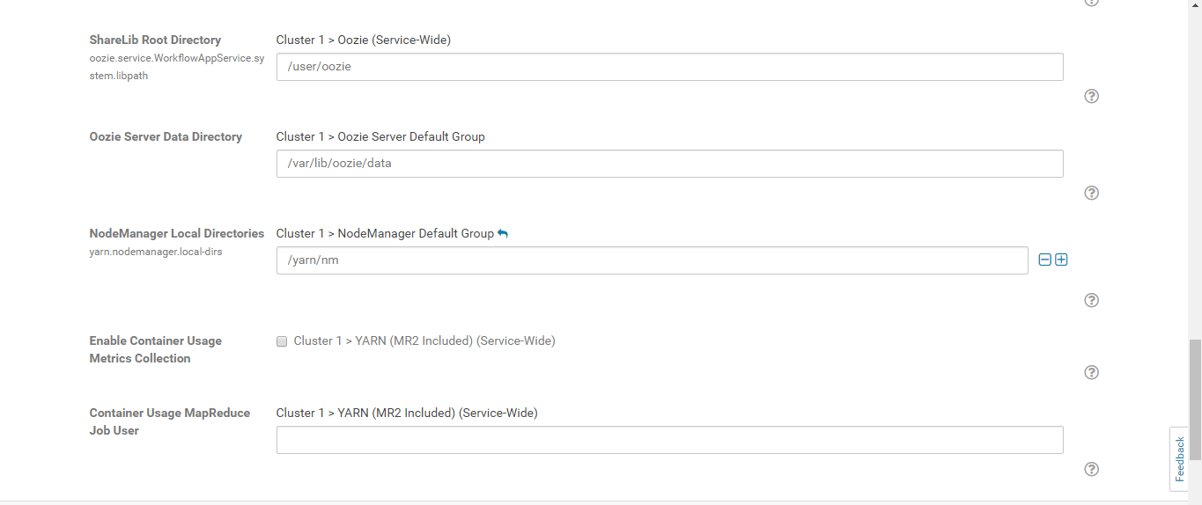

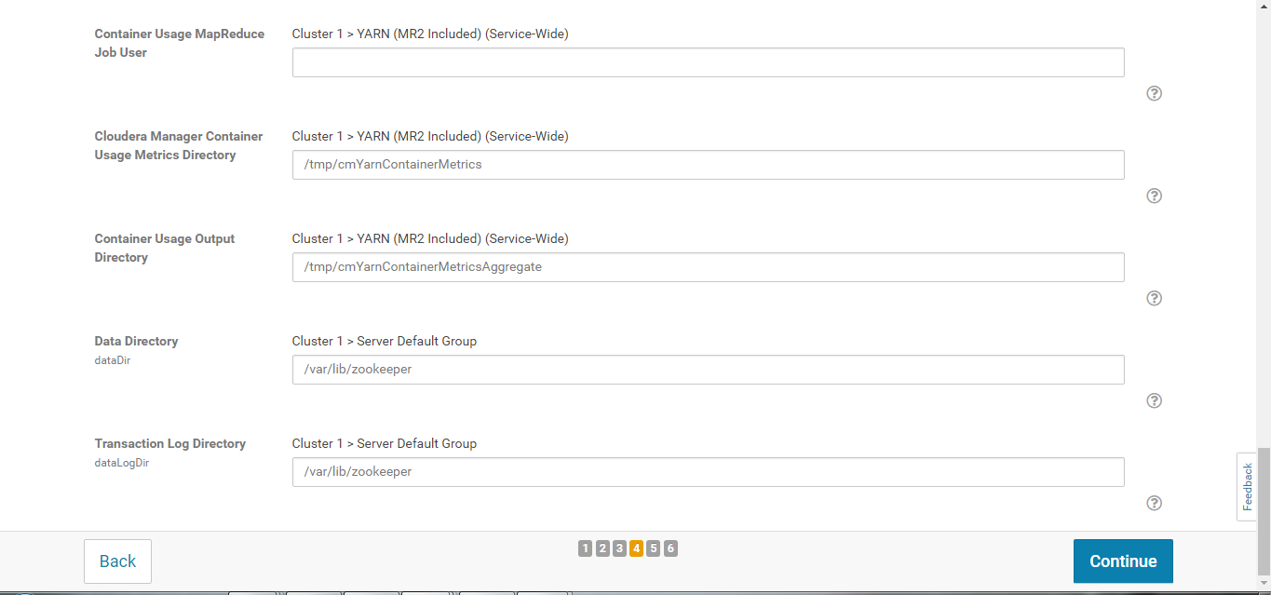

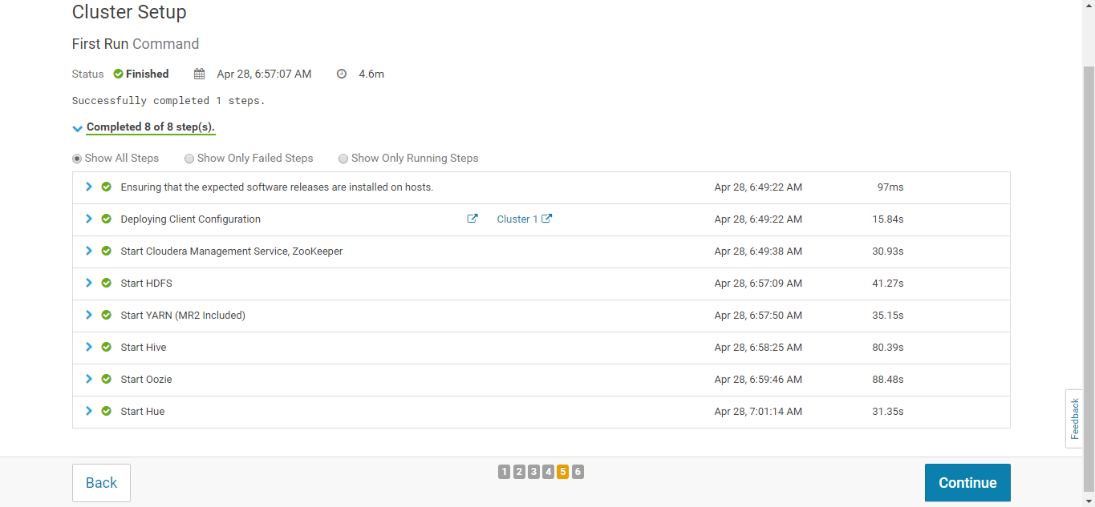

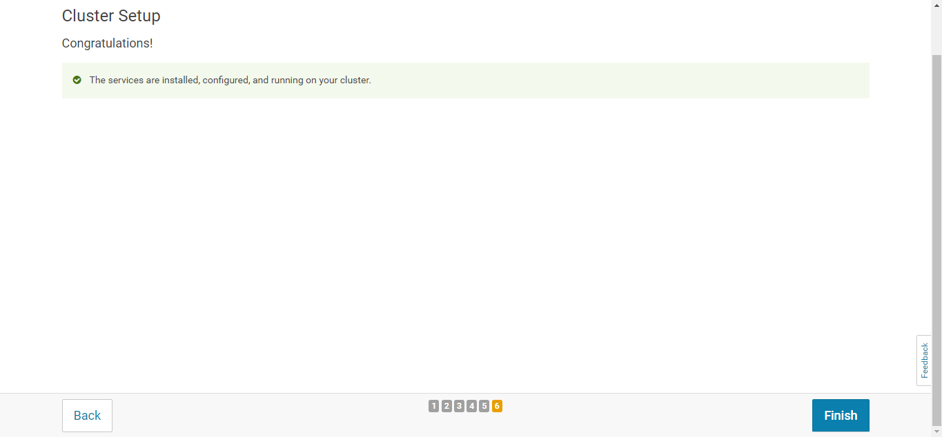

********************** Done******************************************************